**3.7.1 Exercises**

1. What is the default geom associated with stat_summary()? How could you rewrite the previous plot to use that geom function instead of the stat function?

# The stat_summary is associated with geom_pointrange

ggplot(data = diamonds) +

geom_pointrange(

mapping = aes(x = cut, y = depth),

stat = "summary",

fun.ymin = min,

fun.ymax = max,

fun.y = median

)

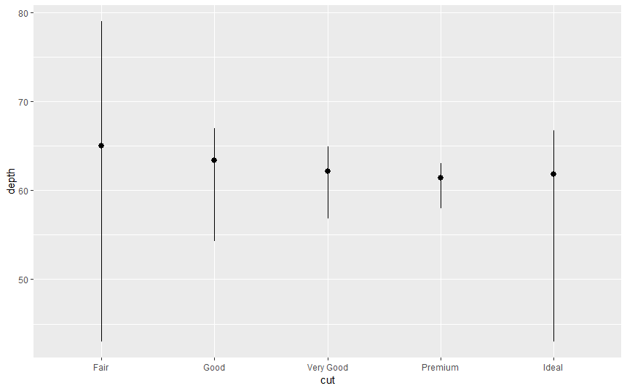

1. What does geom_col() do? How is it different to geom_bar()?

geom_bar makes the height of the bar proportional to the number of cases in each group while [geom_col](http://127.0.0.1:39984/help/library/ggplot2/help/geom_col) makes the heights of the bars to represent values in the data.

The geom_col () function has different default stat than geom_bar() . The default stat of geom_col() is stat_identity(), which leaves the data as is. The geom_col function expects that the data contains x values and y values which represent the bar height.

The default stat of geom_bar is stat_bin. The geom_bar() function only expects an x variable.The stat, stat_bin(), preprocess input data counting the number of observations for each value of x. The y aesthetic uses the values of these counts.

1. Most geoms and stats come in pairs that are almost always used in concert. Read through the documentation and make a list of all the pairs. What do they have in common?

|  |  |
| --- | --- |
| Geom | Stat |
| `geom_bar()` | `stat_count()` |
| `geom_bin2d()` | `stat_bin_2d()` |
| `geom_boxplot()` | `stat_boxplot()` |
| `geom_contour()` | `stat_contour()` |
| `geom_count()` | `stat_sum() |
| `geom_density()` | `stat_density()` |
| `geom_density_2d()` | `stat_density_2d()` |
| `geom_hex()` | `stat_hex()` |
| `geom_freqpoly()` | `stat_bin()` |
| `geom_histogram()` | `stat_bin()` |
| `geom_qq_line()` | `stat_qq_line()` |
| `geom_qq()` | `stat_qq()` |
| `geom_quantile()` | `stat_quantile()` |
| `geom_smooth()` | `stat_smooth()` |
| `geom_violin()` | `stat_violin()` |
| `geom_sf()` | `stat_sf()` |

1. What variables does stat_smooth() compute? What parameters control its behaviour?

The function `stat_smooth()` calculates the following variables:

- `y`: predicted value

- `ymin`: lower value of the confidence interval

- `ymax`: upper value of the confidence interval

- `se`: standard error

The "Computed Variables" section of the `stat_smooth()` documentation contains these variables.

The parameters that control the behavior of `stat_smooth()` include

- `method`: the method used to

- `formula`: the formula are parameters such as `method` which determines which method is used to calculate the predictions and confidence interval, and some other arguments that are passed to that.

- `na.rm`:

1. In our proportion bar chart, we need to set group = 1. Why? In other words what is the problem with these two graphs?

If `group = 1` is not included, then all the bars in the plot will have the same height, a height of 1.

The function `geom_bar()` assumes that the groups are equal to the `x` values since the stat computes the counts within the group.

**ggplot**(data = diamonds) +

**geom_bar**(mapping = **aes**(x = cut, y = ..prop..))

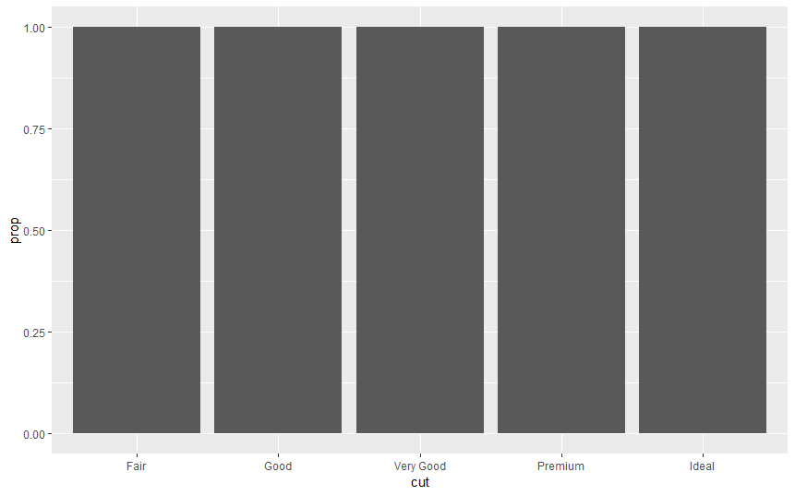

The problem with these two plots is that the proportions are calculated within the groups.

**ggplot**(data = diamonds) +

**geom_bar**(mapping = **aes**(x = cut, fill = color, y = ..prop..))

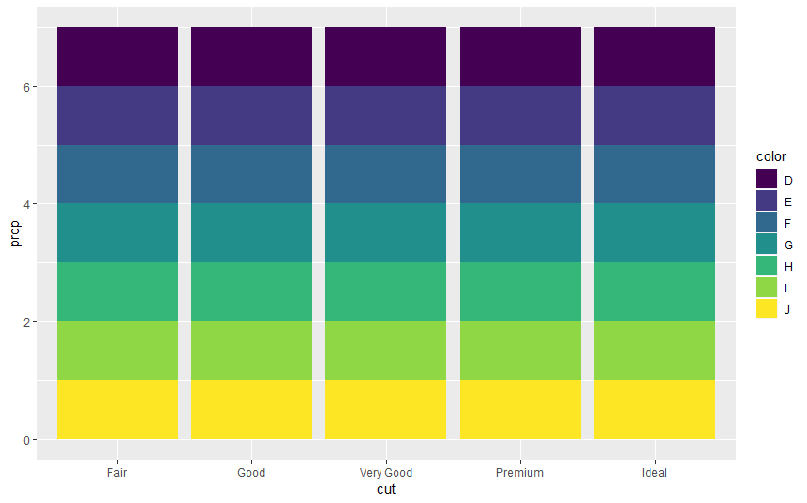

The following code will produce the intended stacked bar charts.

With group

ggplot(data = diamonds) +

geom_bar(mapping = aes(x = cut, y = ..prop.., group = 1))

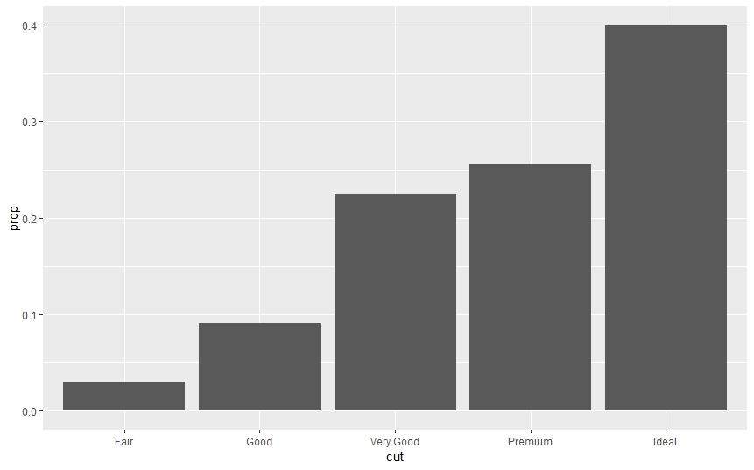

ggplot(data = diamonds) +

geom_bar(mapping = aes(x = cut, fill = color, y = ..prop.., group = color))

